Remote Learning Policy
Our Mission Statement
Our core values are Koinonia, Compassion and Love

Luke 1:37 For with God, nothing shall be impossible

Together we grow stronger, believing that with God nothing is impossible. This extends across all we do; academically, spiritually and emotionally. By the end of their journey, we want our children to be respectful, resilient role-models, having a self-belief in themselves and abilities, ready to go from strength to strength and be truly ready for the next step in their learning journey. This is brought together through our core values of koinonia, compassion and love.

Proverbs 22:6 Start children off the way they should go.

Here at All Saints’, we believe that starting children off the way they should go starts here. In our school community, we are proud of our All Saints’ family feel. The central element of being a family, the true meaning of koinonia, is interdependence and at All Saints’, every one of us is needed and valued and each person is important to the whole.
Ephesians 4:32 Be kind and compassionate to one another, forgiving each other, just as in Christ God forgave you.

At All Saints’ we look for compassion within ourselves so we care for others and help them. For ourselves, we try to be honest about our mistakes so we can change and improve. We accept that sometimes mistakes can be made and that these mistakes need to be forgiven. Forgiveness was at the heart of everything Jesus did and is at the heart of the Lord’s Prayer, which we say daily.

1 John 4:19-21 We love because he loved us first

We understand the love of God is boundless. The love within our school is one of family and friendship. We believe friendship enables each child to grow and ensures that the unique individuality of each person is recognised, allowing them to flourish.
In our Worship, we thank God for his love; he is the One who created love. It is because of His love that we are able to love each other.

Specific Aims and Purpose of the Policy
- To outline our approach for pupils that will not be attending school, as a result of government guidance or the closure of a class bubble.
- To outline our expectations for staff that will not be attending school due to self-isolation, but that are otherwise fit and healthy and able to continue supporting with the teaching, marking and planning for pupils.
Who is the policy applicable to?

Every child is expected to attend school from September 1st 2020. In line with government guidance, pupils, staff and families should self-isolate if they display any of the following symptoms:
o A continuous, dry cough
o A high temperature above 37.8℃
o A loss of, or change to, their sense of smell or taste
o Have had access to a test and this has returned a positive result for Covid-19

This policy is intended to outline expectations for class bubble or partial school closure, rather than individual cases. Individual pupils who are isolating due to health issues (based on government advice) and choose not return to school in September will be supported on a case by case basis, primarily with the use of assigned work via Google Classroom (Tapestry in EYFS) or ‘paper packs’ which mirror the work being taught to the rest of the class in school. The paper packs can also be send home via email or collected from the school office.

Remote learning for pupils

We will provide links to appropriate remote learning for pupils that are not able to attend school so that no-one need fall behind. In the following points, an outline of the provision will be made and some guidance given on the role of pupils, teachers and parents.

The governors and senior leadership team at All Saints’ C of E Primary School are fully aware that these are exceptional times and would like to make it clear that the completion of work is dependent on good health and ask families to contact us should they need further support. Each family is unique and because of this, should approach home learning in a way which suits their individual needs. We realise that the circumstances that cause our school to close will affect families in a number of ways. In our planning and expectations, we are aware of the need for flexibility from all sides:

• parents may be trying to work from home so access to technology as a family may be limited;
• parents may have two or more children trying to access technology and need to prioritise the needs of young people studying towards GCSE/A Level accreditation;
• teachers may be trying to manage their home situation and the learning of their own children;
• systems may not always function as they should.

Family (pupil/parent/guardian) role
- Where possible, it is beneficial for young people to maintain a regular and familiar routine. All Saints’ C of E Primary School would recommend that each ‘school day’ maintains structure. A suggested timetable will be suggested by the class teacher.
- If a class bubble is isolated/or there is a school closure, the children will be sent home with their home reading book, or they may access Accelerated Reader Online, if families require additional paper and/or stationary, they may request this via the class teacher.
- If possible, pupils will be expected to sign in to Google Classroom at 9am and reply to the teachers ‘good morning’ (video or written) as a form of registration.
- Families will be telephoned by the class teacher if pupils do not access Google Classroom on the first day of Google Classroom use, to support in remote learning, where possible.
- Should anything be unclear in the work that is set, parents/carers can communicate with class teachers via the class email address or via parent enquiries email addresses. They should make clear which year group and subject the question relates to.
- We would encourage parents to support their children’s work, by viewing the work set together, and then making appropriate plans to complete the work. This can include finding an appropriate place to work and, to the best of their ability, supporting pupils with work encouraging them to work with good levels of concentration.
- Every effort will be made by staff to ensure that work is set promptly on appropriate platforms but school cannot guarantee that the chosen platforms will work on all devices. Should accessing work be an issue, parents should contact school promptly and alternative solutions will be made available (e.g. paper copies of work, loan of tablets etc). These will be discussed on case-to-case basis.
- Pupils will hand in English and maths work by the end of the day, if possible.

Teacher role/expectations (Appendix A)

Remote teaching for staff who are self-isolating

Teaching staff are required to self-isolate if they show symptoms outlined at the start of this policy or they have been told to shield and/or have received a letter to confirm this. If a member of staff is required to self-isolate, they are expected to:
- Follow normal reporting procedure for planned absence.
- Following contact with school, the school business manager (SBM), may set up a referral to Occupational Health to support that individual.
- It is expected that staff get tested if they display symptoms of Covid-19. Should a staff member be tested, it is expected, as per national guidance, to share the result of this test with school so that appropriate plans can be made.
- Whilst self-isolating, and if able to do so, non-teaching staff will be given an individual project to work on which is line with whole school improvement priorities or asked to support with the online learning provision for their year group. These projects will be communicated by the Senior Leadership Team and will be allocated on a case-by-case basis. This includes pregnant staff members from 28 weeks.
- If unwell themselves, teachers will be covered by another staff member for the sharing of activities. Communication and planning during this time will not be undertaken until the teacher is fit to work.
- There may be cases whereby teachers deliver lessons via Zoom, this is being trialled in KS2.

Teacher expectations (Appendix A)

Teachers (Years 1-6) will plan lessons that are relevant to the curriculum focus for that year group and endeavour to supply resources to support tasks for home learners. Work for the week in English, Maths and other subjects will be posted on the class website page by 9.00am, each morning:
  - The class teacher will offer a good morning at 9am either written or recorded hellos. Within this, they will include reference to daily tasks for relevant subjects.
  - A link to the year group’s curriculum map which gives a back drop to current study
  - Links to daily English lessons – such as, a mixture of ‘BBC Bitesize’, Oak Academy and Lgfl resources. Lessons may be uploaded that are planned from the All Saints’ Curriculum.
  - Links to daily Maths lessons – these will be a mixture of ‘White Rose’ and Oak Academy, as well as hand-picked online resources that support the learning
Worksheets to accompany lessons should be uploaded as pdfs, but parents should be reminded that printing these is not always necessary.
  - Wider Curriculum-
Each week teachers will include: 5 wider curriculum lessons (R.E., P.E., Art, Design and Technology, Computing, Science, Geography and History)
  - Each day teachers will include:
- a short paragraph outlining the work (see Appendix C),
- a mixture of teacher videos (Oak Academy), PowerPoint slides and worksheets
- teachers will differentiate the work according to pupils needs,
- assign differentiated tasks to pupils,
- provide feedback on pupils’ work (using the comments tool on Google Classroom),
- provide feedback within 2 days of each completed task,
- teachers will label each lesson clearly (English lesson 1 Monday 15/11)
- teachers will create a topic label for each subject on Google Classroom (see Appendix C)
  - Teachers will watch any recorded videos (Oak Academy) prior to using them to ensure they support children effectively and follow All Saints’ C of E School practices.
  - Teachers will already have a 1-day pack prepared, which is uploaded on the school system. This pack will include: 1 English lesson, 1 maths lessons, 1 comprehension lesson and 2 wider curriculum lessons.
  - If Nursery or a Reception class is self-isolating teachers will use Tapestry to provide pupils with remote learning packs (see Early Years section).

Early Years
In the EYFS much of our learning takes place through carefully planned free choice play based activities that link to the key skills we are working on that week and reflect the Development Matters Curriculum. To reflect this the home learning activity grids are put together, linking to our weekly key text, with ideas for practical learning experiences to both reinforce the key text and incorporate all the different areas of the curriculum.
We understand that our youngest children cannot access learning resources online without the support of their adults so printable worksheets and activities will also be included. Many activities relevant for children in the EYFS rely heavily on adult involvement, so teachers will be understanding of different family circumstances. Many of our activities will need an adult to set up the activity for the child to access it. We bare this in mind when setting expectations.

In the EYFS many children’s attention spans will be limited to around 15 minutes, so it is expected that children will intersperse these activities with free-choice play and physical development activities. Nursery children are usually only in school for 3 hours a day, so online learning expectations will reflect this shorter day.

  - The class teacher will offer a good morning at 9am either written as a post on tapestry or a recorded video. Within this, they will include reference to the activity grid and any suggested daily activities (see Appendix E and F).
  - Teachers will provide links to the key text for English lessons to be watched daily. This could be a link to the story being read online (for example on youtube) or a video of the teacher reading the story uploaded to Tapestry.
  - Reception will provide links to daily Maths lessons – these will be a mixture of ‘Numberblocks’ and Oak Academy, as well as hand-picked online resources that support the learning and worksheets to accompany lessons (Appendix G). Nursery will provide links to ‘Numberblocks’ and other hand-picked online resources such as songs.

  - Wider Curriculum-
Each week teachers will include: 4/5 wider curriculum activity ideas for parents (R.E., gross motor, fine motor, Expressive Arts and Design, Understanding the World) (Appendix G)
Each day teachers will:
- Welcome families using Tapestry (written or recorded)
- Provide a mixture of teacher videos, activity ideas and worksheets,
- assign differentiated tasks to pupils where necessary to meet individual needs,
- provide feedback on observations uploaded by parents using the comment function of tapestry

  - Teachers will watch any recorded videos (Oak Academy) prior to using them to ensure they support children effectively and follow All Saints’ C of E School practices.
  - Teachers will already have a generic 1 week activity grid linked to a key text prepared and saved on the shared system

- Any resources used, including websites and worksheets, should, where possible, be shared with home learners via pdf documents which can be downloaded on smart devices easily. Staff will add these resources to Tapestry electronically using the memo function and it will be the responsibility of families to print/use these resources at home (or contact the school to ask for a ‘paper pack’)
- Teachers will respond promptly, within reason (allow up to three days), to requests for support from families at home. This should be done via class email addresses. Staff and parents should communicate via the class email address (provided when necessary).
- Should a staff member require support with the use of technology, it is their responsibility to seek this support in school and Senior Leaders will ensure that support is given promptly.
- Tapestry open hours are 8am-7pm
- Teachers are expected to promote e-safety in line with the e-safety policy.
- Any safeguarding concerns should be reported immediately in line with the school’s safeguarding policy.
- Teacher’s need to be responsible for their own well-being and work-life balance and should adhere to the suggested open hours of Tapestry.
- Teachers will contact families via telephone if they have not activated their Tapestry account or have any other concerns.

Teachers will plan activities that are relevant to the key text focus for that year group and endeavour to supply resources to support tasks for home learners. Work for the week in Literacy, Maths and other areas of the EYFS curriculum will be posted on Tapestry in the memo section by 9.00am on a Monday morning.

- Any resources used, including websites and worksheets, should, where possible, be shared with home learners via pdf documents which can be downloaded on smart devices easily. Staff will add these resources to their Google Classrooms electronically and it will be the responsibility of families to print/use these resources at home (or contact the school to ask for a ‘paper pack’)
- Teachers will respond promptly, within reason (allow up to three days), to requests for support from families at home. This should be done via class email addresses. Staff and parents should communicate via the class email address (provided when necessary).
- Should a staff member require support with the use of technology, it is their responsibility to seek this support in school and Senior Leaders will ensure that support is given promptly.
- Google Classroom open hours are 8am-7pm
- Teachers are expected to promote e-safety in line with the e-safety policy.
- Any safeguarding concerns should be reported immediately in line with the school’s safeguarding policy.
- Teacher’s need to be responsible for their own well-being and work-life balance and should adhere to the suggested open hours of Google Classroom.
- Teachers are expected to attend and action staff training which leads to the creative use of Google Classroom.
- Teachers will contact families via telephone that do not access Google Classroom on the first day of use, to support in remote learning, where possible.

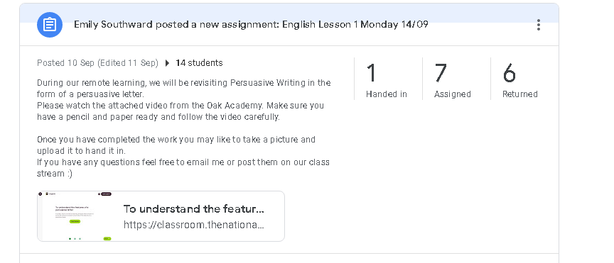
Appendix B

Appendix C

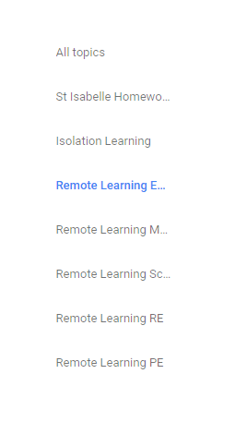
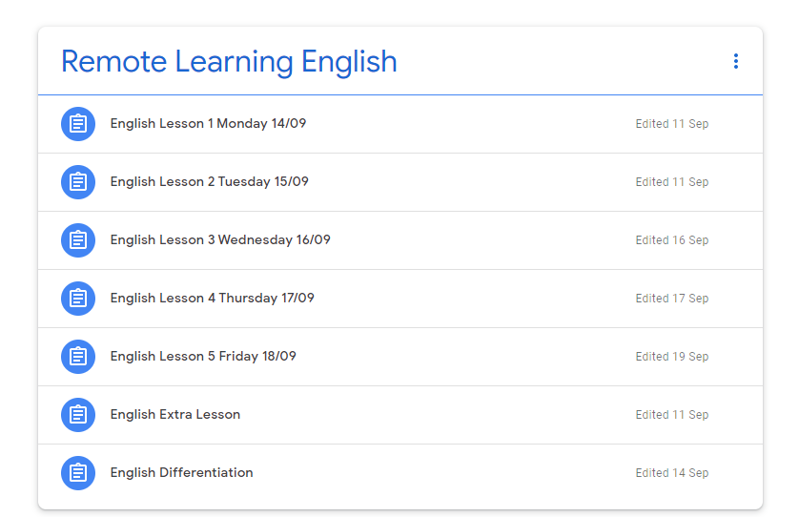

Parent Guide to Google Classroom
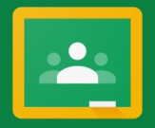
Appendix D
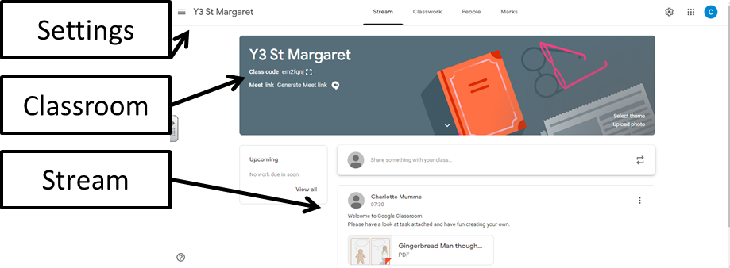
What is Google Classroom?

Google Classroom is a web-based platform that aims to simplify creating, distributing and assessing learning in a paperless way. Teachers can use Google Classroom to send announcements to entire classes, share resources, lesson notes, PowerPoints, diagrams, and home learning. Children can use it to access work covered in class in school, at home or on the go and complete home learning. Parents can use some of the features of Google Classroom to help engage with and support children in their home learning. It is a free resource that can be accessed from any device connected to the internet - laptops, desktop computers, chromebooks, tablets or mobile phones.

What is G Suite for Education?

G Suite for Education is a set of Google apps: Docs, Sheets, Slides, Drive, Classroom, Calendar, and more designed with intelligent features that make work easier. It is a suite of tools that can help increase opportunities for critical thinking, communication, collaboration, and creativity, all while supporting the learning. ​Gmail will not be enabled​ for children at this time.
G Suite for Education tools are: ​free​,​ ad-free​,​ reliable ​and​ secure​. These tools are already used by millions of children in schools around the world. There is no cost to use this service, but the best thing is that these tools are relevant to children, easy to use, and open doors to many new ways to learn.

Accessing Google Classroom

Children can access Google Classroom using the mobile apps (Android and iOS), or via a web browser by visiting ​www.classroom.google.com​. They should sign in using their ​@allsaints.merton.sch.uk email address. When accessing for the first time, follow the ‘step by step’ guide.
Once children have logged in, they will see the class overview page. From here they can see all of the classes they are registered with, a summary of any work . Clicking on a class will open that Classroom.
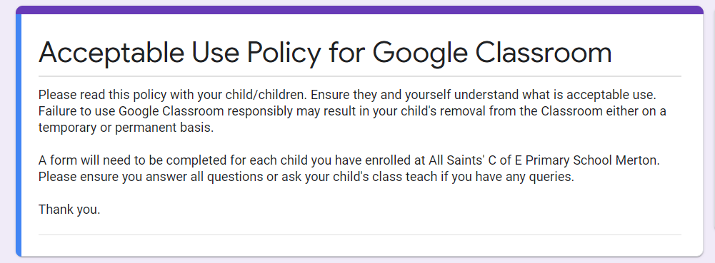
Appendix E
If you have any questions or comments please feel free to email ​or ring the office and direct your comments to Charlotte Mumme (Computing subject leader) and Emily Southward.
Although many safety features have been enabled by our administrators, it is still the responsibility of parents to monitor what children are accessing online at home. We will continue to teach children the importance of being responsible digital citizens and accessing age appropriate material and we appreciate parents supporting this at home with their children.
Google Classroom and G suite for Education is fully compliant with GDPR. Google builds and operates its own secure servers and platform services and make it easy to monitor and manage data security.
The children’s Gmail accounts have a particular set of security settings to reflect the fact that the system is being used by a child - they have a much higher security setting. Although children have a Gmail login, they do not have access to a Gmail Account. Further details can be found here.
Accessing resources

If children are accessing Google classroom from a mobile device, they should download the appropriate Google Apps to make best use of the shared resources. The most useful Google apps are: Classroom, Calendar, Docs and Drive.
To open any task, click on the ​‘Assignment’ symbol on the appropriate post in the Stream page.

You will then see the task description and any attached documents. You can complete a task in any way you like. Nursery, Reception and KS1 children are still developing their fine motor skills, so it would be beneficial to complete work on paper. On completion of the task, click on the ‘mark as done’ button and you can ‘add attachment’ and upload a photograph of their work.
Children in KS2 may wish to complete the task online. Open the attachment and complete your assignment in this document. When you are finished, click on the ’mark as done’ button. You can even add your own attachments to your submission, such as photos, audio clips, videos, etc. Once the task has been marked by the teacher, you can see feedback and any comments made by the teacher by opening the task as before.

Safety Features

Why have we chosen to do this?
1. Enable teachers, parents and children to celebrate successes, work and comment on learning.
2. Prepare our children for secondary school home learning.
3. Motivate children to complete their learning in a format that is engaging.
We felt that this would be a wonderful way to see children’s home learning and for teachers to remain in contact with children.
Increasingly, secondary schools are expecting their home work to be completed online and feedback throughout the borough was that primary school children are not equipped to handle this transition. Google apps have been used successfully in many other schools in the borough for many years. They have been tried and tested and shown to be a really useful and secure way of engaging children in their home learning.

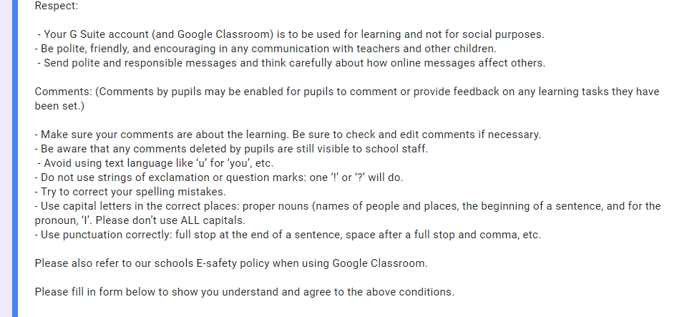
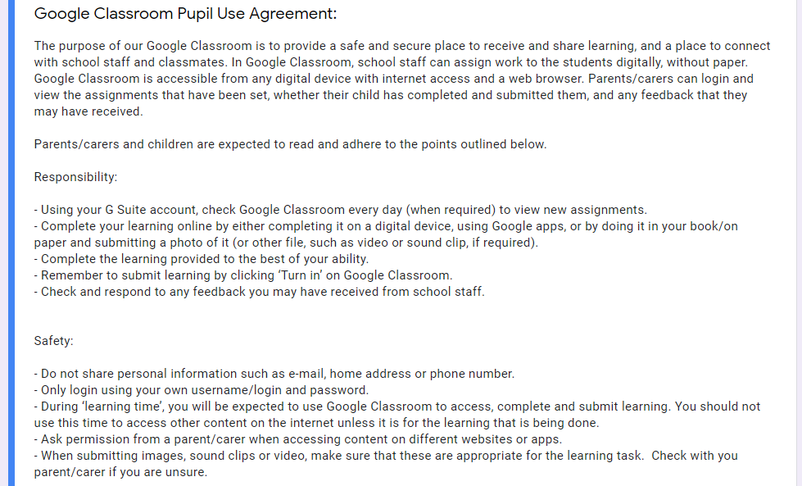
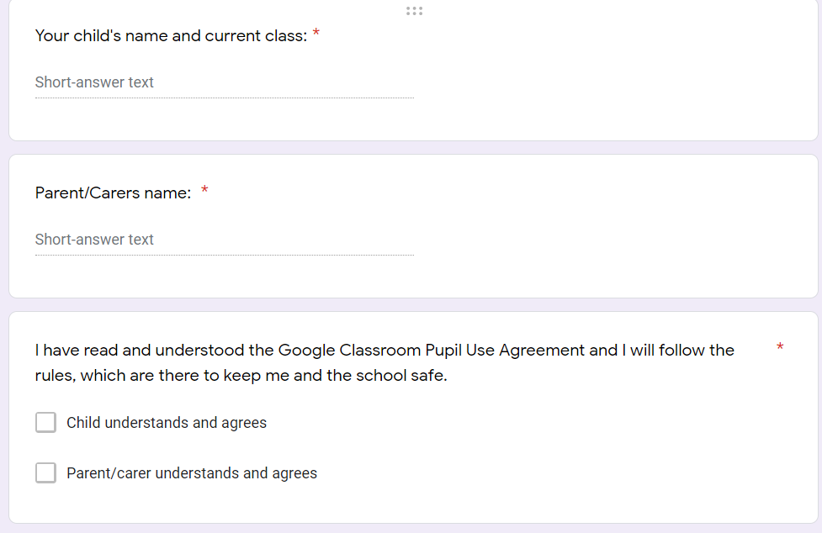
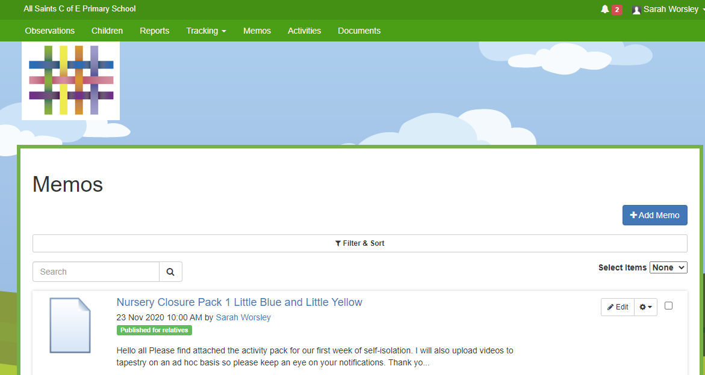
Appendix F

Appendix G
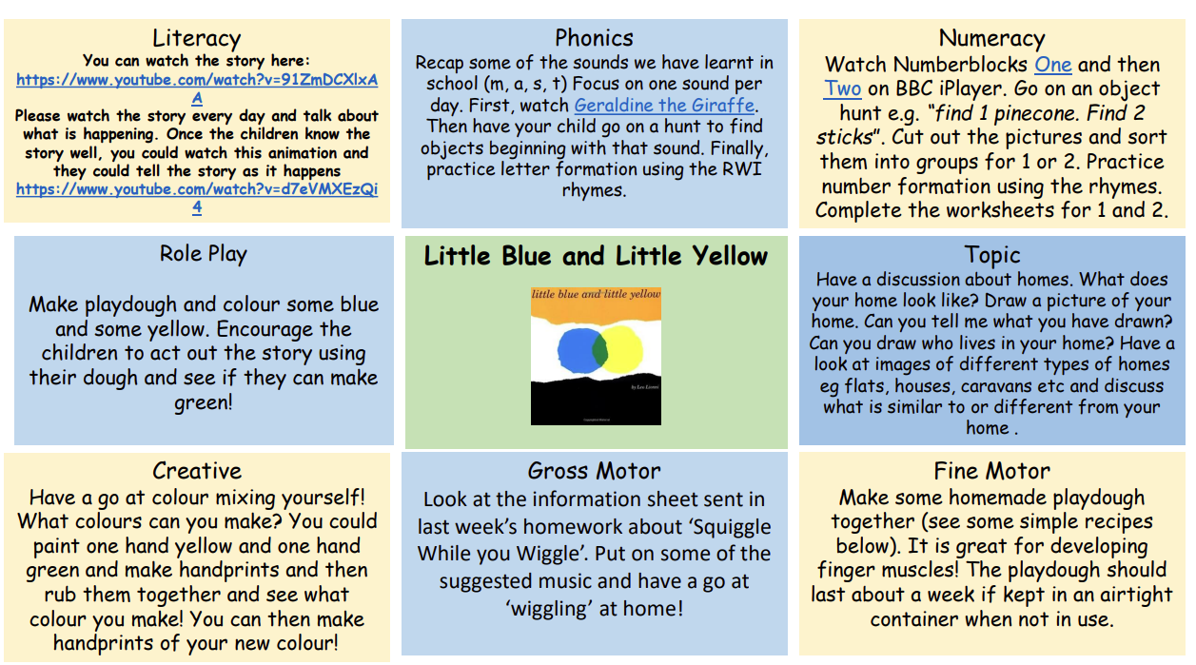
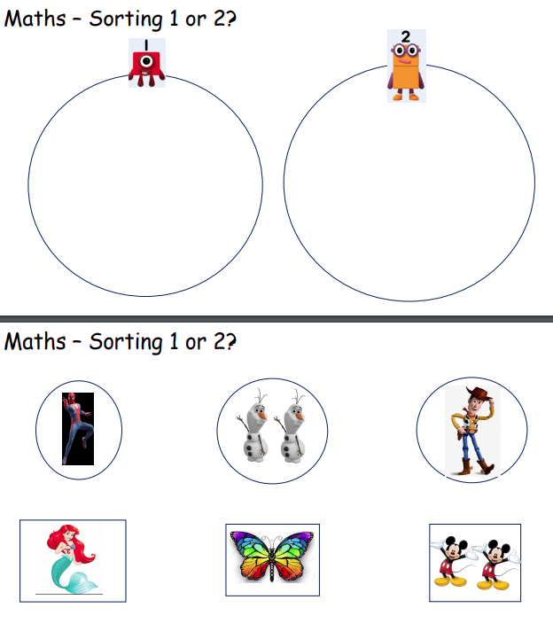
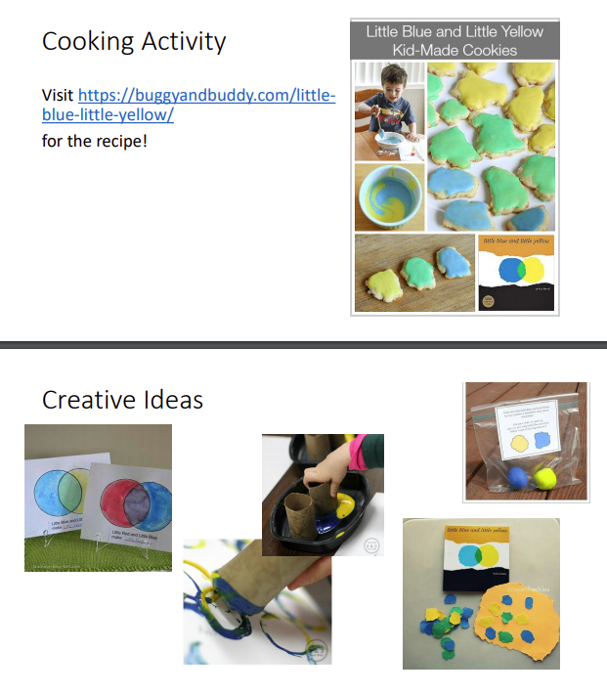
Appendix H

Appendix I
Information on Google’s Privacy Policy
We use G Suite for Education - a set of education productivity tools from Google including Gmail, Calendar, Docs, Classroom, and more used by tens of millions of students and teachers around the world. Children will use their G Suite accounts to complete assignments, communicate with their teachers and learn 21st century digital citizenship skills, using mostly Google Classroom.
We use a special version of the core G Suite Apps to provide a secure learning intranet for our children and staff.
Children use a Gmail login to access our system servers and the intranet and internet in school. With school Gmail and Google Docs, for example, work cannot be shared with external email accounts, only with others within @allsaints.merton.sch.uk - the school’s Google domain. Google require basic information to set up these accounts, your child’s leaving year and name.
Google Cloud does contain much of the electronic work that your child completes in school. By logging in at home, using the same login as at school, your child can access home learning more efficiently, often using one of the main apps of G Suite, Google Classroom.
Our children’s accounts have a particular set of security settings to reflect the fact that the system is being used by a child - they have a much higher security setting than our staff for example. We take advice on these settings from companies that advise us.
Google’s Privacy Policy for GSuite can be found here: https://policies.google.com/privacy/update
The information below from Google provides answers to common questions about what they can and can’t do with your child’s personal information, including:
- What personal information does Google collect?
- How does Google use this information?
- Will Google disclose my child’s personal information?
- Does Google use student personal information for users in K-12 schools to target advertising?
- Can my child share information with others using the G Suite for Education account?

G Suite for Education information for Parents and Guardians
This notice describes the personal information we provide to Google for these accounts and how Google collects, uses, and discloses personal information from pupils in connection with these accounts.
Using their G Suite for Education accounts, pupils may access and use the following “Core Services” offered by Google Classroom (described at https://gsuite.google.com/terms/user_features.html):
- Gmail
- Calendar
- Docs
- Sheets
- Slides
- Forms
- Drive
- Sites
Google provides information about the information it collects, as well as how it uses and discloses the information it collects from G Suite for Education accounts in its G Suite for Education Privacy Notice. You can read that notice online at https://gsuite.google.com/terms/education_privacy.html You should review this information in its entirety, but below are answers to some common questions:

What personal information does Google collect?
When creating a child’s account, we provide Google with certain personal information about our children, including, for example, a name, email address, and password. Google may also collect a profile photo added to the G Suite for Education account, but the school will not support the upload of personal photos of children.
When a pupil uses Google services, Google also collects information based on the use of those services. This includes:
- device information, such as the hardware model, operating system version, unique device identifiers, and mobile network information including phone number;
- log information, including details of how a user used Google services, device event information, and the user's Internet protocol (IP) address;
- location information, as determined by various technologies including IP address, GPS, and other sensors;
- unique application numbers, such as application version number; and
- cookies or similar technologies which are used to collect and store information about a browser or device, such as preferred language and other settings.

How does Google use this information?
In G Suite for Education Core Services, Google uses student personal information to provide, maintain, and protect the services. Google does not serve ads in the Core Services or use personal information collected in the Core Services for advertising purposes.

Does Google use pupil personal information for users in primary schools to target advertising?
No. For G Suite for Education users in primary and secondary schools, Google does not use any user personal information (or any information associated with an G Suite for Education Account) to target ads, whether in Core Services or in other Additional Services accessed while using an G Suite for Education account.

Can my child share information with others using the G Suite for Education account?
We allow pupils to access Google services such as Google Docs and Sites, which include features where users can share information with others within our Internet domain here at All Saint’s. Although children have a Gmail login, they do not have access to a Gmail Account.

Will Google disclose my child’s personal information?
Google will not share personal information with companies, organisations and individuals outside of Google unless one of the following circumstances applies:
- With parental or guardian consent. Google will share personal information with companies, organisations or individuals outside of Google when it has parents’ consent which may be obtained through G Suite for Education schools - including All Saint's. We would contact parents directly if Google ask for any examples of children's work etc.
- With All Saint’s C of E School G Suite for Education accounts, because they are school-managed accounts, give administrators access to information stored in them.
- For external processing. Google may provide personal information to affiliates or other trusted businesses or persons to process it for Google, based on Google’s instructions and in compliance with the G Suite for Education privacy notice and any other appropriate confidentiality and security measures.
- For legal reasons. Google will share personal information with companies, organisations or individuals outside of Google if it has a good-faith belief that access, use, preservation or disclosure of the information is reasonably necessary to:
  - meet any applicable law, regulation, legal process or enforceable governmental request.
  - enforce applicable Terms of Service, including investigation of potential violations.
  - detect, prevent, or otherwise address fraud, security or technical issues.
  - protect against harm to the rights, property or safety of Google, Google users or the public as required or permitted by law.
Google also shares non-personal information -- such as trends about the use of its services -- publicly and with its partners.

What choices do I have as a parent or guardian?
When you first login, you can consent to the collection and use of your child’s information by Google. If you don’t provide your consent, it will not create a G Suite for Education account for your child, and Google will not collect or use your child’s information as described in this notice.
If you consent to your child’s use of G Suite for Education, you can access or request deletion of your child’s G Suite for Education account by contacting Mrs Charlotte Mumme or Miss Emily Southward.
If you wish to stop any further collection or use of your child's information, you can request that we use the service controls available to limit your child’s access to features or services, or delete your child’s account entirely. You and your child can also visit https://myaccount.google.com while signed in to the G Suite for Education account to view and manage the personal information and settings of the account.

What if I have more questions or would like to read further?
If you have questions about our use of Google’s G Suite for Education accounts or the choices available to you, please contact Mrs Charlotte Mumme or Miss Emily Southward.
If you want to learn more about how Google collects, uses, and discloses personal information to provide services to us, please review the G Suite for Education Privacy Center, the G Suite for Education Privacy Notice, and the Google Privacy Policy.
The Core G Suite for Education services are provided to us under Google’s Apps for Education agreement.

Acceptable use policy for Google classroom and Google Classroom Rules:
Children have been made aware of online behaviour, however it is relevant that you are also aware.
Pupils need to know:
Pupils will follow school policies for appropriate use when using Internet based services like Web 2.0 applications & Google Apps. These services are considered an extension of the school’s network.
Pupils have no expectation of privacy in their use as school and service administrators have the right and ability to monitor user accounts for policy and security enforcement, whether they access these in school or at home.
Parents need to know:
Parents will read the Acceptable use policy for Google Classroom with their child and sign that they understand what is acceptable use. School staff will monitor pupil use of applications when students are at school. Parents are responsible for monitoring their child’s use of applications when accessing programs from home; the school cannot take responsibility for home Internet access and its setup. Pupils are responsible for their own behaviour at all times.

