
Games and Activities for Parents

London Grid for Learning has a range of fun maths games and resources for EYFS to Years 6. The resources and split into different maths topics. https://mathsathome.lgfl.org.uk/main.html

Below is a list of games we have found for you to use at home. Most resources needed for these games are included in your goody bags and where they’re not, household items can be used instead (e.g. dried pasta etc.).

To help number bonds:

Play in pairs. Each draw 10 circles. Write a different 2-digit number in each circle – but not a ‘tens’ number (10, 20, 30, 40…). In turn, choose one of the other player’s numbers. The other player must then say what to add to that number to make 100. E.g. choose 64, add 36. If the other player is correct, they cross out the chosen number. First to cross out 6 numbers wins. Introduce a time limit to challenge them.
Using a 1-6 dice, play in pairs and take turns rolling the dice. See how quickly you can say the
number to add to the number on the dice to make 10. Extend by doing number bonds to 20, 50, 100 etc.
Using the blank playing cards, make a set of 12 cards, showing the numbers 0-10, but with
two 5s. Shuffle the cards and give them to your child. Time how long it takes to find all the pairs (number bonds) to 10. Repeat later in the week and see if they can beat their time. To extend them, use number bonds to 100, 20 and 50.
For this game, you need to write out numbers 1- 20 on blank cards and spread them out on the table face up. Take turns. Roll 2 dice and add the numbers together. Put a coin/counter on the number that goes with the dice number to make 20, e.g. throw a 2 and a 3 makes ‘5’ so you would put a coin/counter on 15. If someone else’s counter is there already, replace it with
yours! The first person to have counters on 6 different numbers wins.

To help place value:

Beat that! Play in pairs or more. Have a sheet with 5 gaps on (or use a whiteboard) for each person.
E.g. Player 1 - Player 2
You are both trying to make the biggest 5-digit number you can (start off with 3-digit numbers if child is year 3 or 4). Take turns rolling a die. You have to decide where to put your
digit, and you can put it in your partner’s number if you want!

To help times tables:

Roll two dice. Multiply the numbers together – cross off from a list of numbers or put counters on them – maybe a multiplication grid or 1-100 grid or a list you have come up with
together.
Same as above but shuffle the 1-12 number cards and place them face down. Pick two and multiply them together.
Draw – Stand facing each other with your hands behind your back. After 1,2,3,draw, put your hands out in front of you holding up as many fingers as you like. First one to multiply the total of your fingers by the other person’s fingers wins! Can also use for adding and subtracting (find the difference between them).
Bingo!
One person has the 2x table (for example) and the other has the 5x table. Write six numbers in that table on your piece of paper or whiteboard. No more than 12x the number. Roll 2 dice and add the numbers. Multiply that number by whatever times table you’re doing. E.g. 2 x 7 or 5 x 7. If the answer is on your whiteboard, cross it out. The first to cross out all six of their
numbers wins.
If you have dominoes at home, shuffle them and put them face down. Each person picks a domino and multiplies the numbers together. The person with the biggest answer keeps the two dominoes. The winner is the person with the most dominoes at the end.
Share playing cards out between two people. Each person puts a card down. The first person to work out what those two numbers multiplied together are gets to keep the cards.

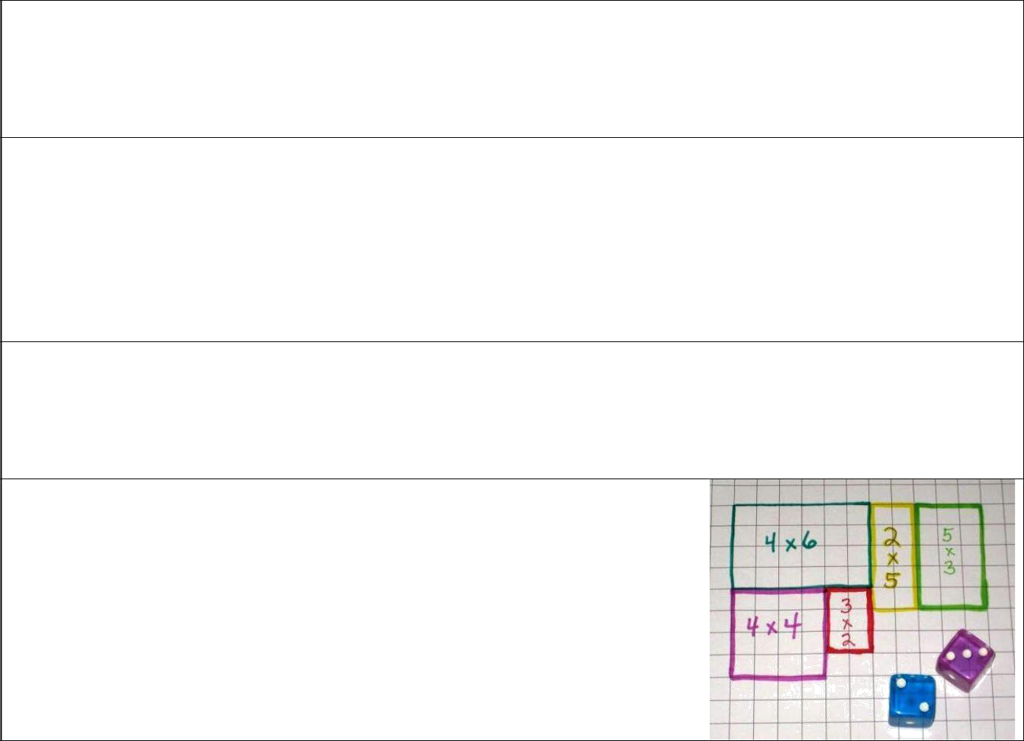
Using blank cards, write multiplication questions on half the cards (e.g. 4 x 3) and the answers on the other half (e.g. 12), then shuffle them all, lay them out upside down and play a matching game. Also helps memory. Can also use them as a timed game – can your child beat their time from last time?

Multiplication high fives - http://creeksidelearning.com/multiplication-games/ - Get your child to draw round their hand and put a product of a times table inside the hand. Do lots of these and put them up around the house. They then have to go round, give the hand a high five and say the multiplication question that goes with the answer. Can do it on different coloured paper, or decorate the hands to make them stick in their minds.

Snap - http://topnotchteaching.com/lesson -ideas/math-games/ - use a deck of normal playing cards with the K, Q and J removed. Shuffle and put them in two piles face down. Take turns turning over the first two cards; first one to multiply the numbers together keeps the cards.

Use squared paper and 2 dice. Roll the dice and on the squared paper, draw a rectangle to show the multiplication e.g. 2 and 3 = 2 x 3 so draw a rectangle 2 squares by 3 squares. Say the answer and count the squares to check. Take it in turns and whoever finishes the large rectangle wins. Helps to link times tables with area too.

To help calculations (addition, subtraction, multiplication and division):

Once a week, tip out the small change from a purse. Count it up with your child.
After you have been shopping, choose 6 different items each costing less than £1. Make a
price label for each one. E.g. 39p, 78p etc. Shuffle the labels. Then ask your child to do one of the following:
- Place the labels in order, starting with the lowest
- Say which price is an odd number and which is an even number
- Add 9p to each price in their head (by rounding it to 10, adding 10 then taking away 1)
- Take 20p from each price in their head
- Say which coins to use to pay exactly for each item
- Choose any two of the items, and find their total cost
- Work out the change from £1 for each item
Draw four circles each on your piece of paper or whiteboard. Write four numbers between 3 and 18, one in each circle.
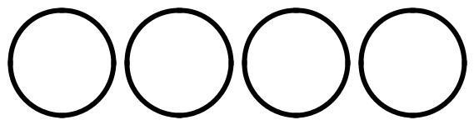

Take turns to roll a dice three times and add the three numbers. If the total is one of the
numbers in your circles, then you may cross it out. The first to cross out all four circles wins.
Use dried pasta, counters, buttons, sweets etc. Start with a pile of pasta, counters etc in the middle. Count them. Throw a 1- 6 dice. Say how many pieces of pasta will be left if you subtract that number. Then take the pieces away and check if you were right. Keep playing and the
person to take away the last piece wins!
Roll 2 dice. Make a 2-digit number. E.g. if you roll a 6 and 4, this could be 64 or 46. Then ask your child to do one of the following things:
- Count on or back from each number in tens.
- Add 19 to each number in their head. (A quick way is to add 20 then take away 1)
- Subtract 9 from each number. (A quick way is to take away 10 and add 1)
- Double each number
- Challenge them to half the number – especially if it’s an even number.
Use the 1-100 grid. Play in pairs. Use 2 counters and start on 1. Toss a coin. If it lands on heads, move 1 place along. If it lands tails, add 10, saying the total correctly before moving.
First person to reach the bottom row wins.
Secret numbers!
Ask your child to say a number. E.g. 43. Secretly do something to it (e.g. add 30.) Say the answer, e.g. 73. The child then says another number to you, e.g. 61. Do the same to that number and say the answer. The child has to guess what you are doing to the number each
time! Then they can have a turn at secretly doing something to a number that you say to them.
Dicey Division
You each need a piece of paper. Each of you choose 5 numbers from the list below and write them on your paper:
5, 6, 8, 9, 12, 15, 20, 30, 40, 50
Take turns to roll a dice. If the number you roll divides exactly into one of your numbers, then cross it out, e.g. you roll a 4, it goes into 8, cross out 8. You can only cross out one
number per roll. If you roll a 1, miss that go. The first to cross out all five of their numbers wins.

Each player needs a dice. Say Go! Then each rolls a dice at the same time. Add up all of the numbers showing on your own dice, at the sides as well as at the top. Whoever has the highest total scores 1 point. First to get 10 points wins.
Whilst shopping, point out an item costing less than £1. Ask your child to work out in their head the cost of 3 items. Ask them to guess first. See how close they come.
Roll a dice 6 times and write down the digits you roll. Use the 6 digits to make two 3-digit numbers. Add the two numbers together. How close to 1000 can you get?
101 and out…
To play, you will need a sheet of paper, a pencil, and one dice. The object of the game is to score as close to 101 without going over or "out." To play, you take turns rolling the dice. As you roll, either take the number as a one or a ten. For example, if someone rolls a 5, they could take it as a 5 or a 50.
Players keep a running record of their total as they play.
Guess my number!
To play, you need a 1-100 grid and a whiteboard pen. To begin, one player chooses a number. The other players try to guess the number by asking a series of questions. The players who are guessing cross off numbers it can't be and circle numbers it could. The person who guesses the right number, wins and gets to choose the next number. Try varying the types of questions. E.g. is it a multiple of 5? Is it divisible by 3? Is it greater than 50? Is 6 one of its factors? Is it even?
Squares game:
http://games4gains.com/blogs/teaching-ideas/41372740- weve-mathified-the-squares-game
Pig!
Players take turns rolling two dice and following these rules: On a turn, a player may roll the dice as many times as he or she wants, mentally keeping a running total of the sums that come up. When the player stops rolling, he or she records the total and adds it to the scores from previous rounds. But, if a 1 comes up on one of the dice before the player decides to stop rolling, the player scores 0 for that round and it's the next player's turn. Even worse, if a 1 comes up on both dice, not only does the turn end, but the player's entire accumulated total returns to 0. Use 2 die and roll them 3 times, each time adding up the totals until you get the total from 6 die (if you have another 4 die at home then roll them altogether). The person with the biggest total wins.
Roll a dice three times. They try to make the biggest and smallest number possible, and then subtract. Excellent proof of knowledge for place value and 3 digit subtraction!
99. Play in pairs. Each player writes 99 at the top of whiteboard or paper. 1st player rolls 2 dice and adds the numbers together to find the sum. Then, they subtract this number from
99. They then write their new result underneath 99. Keep taking it in turns and first player to get to 0 or beyond is the winner!
Countdown. Based on the numbers section of the Channel 4 programme. There is an online version on the Websites and Apps sheet in goody bag. You can also play it using your dice: Randomly generate a 2 digit number by rolling a die 2 times (or 3 times for a bigger challenge!). Roll your die 6 times, recording the numbers rolled on a whiteboard then using the numbers in any combinations you like (adding, taking away, multiplying, dividing) see how close you can get to the target number.

To help fractions:

Use 12 counters, or pasta, sweets etc… Ask your child to find half of the 12 things. Now find one quarter of the same group. Find one third. Repeat with other numbers – making sure the half, quarter and third is a whole number.
Fraction bingo – see fraction bingo boards in goody bag. Available to print more from
http://www.schooltimesnippets.com/2015/01/fractions-bingo-game.html
Roll, Slide and Cover. This is a 2 players game to help identify fractions. Each player takes turns rolling 2 dice, sliding the dice together to make a fraction, then placing a coloured counter onto the matching fraction. If the fraction is already covered, the player misses a turn. The winner is the player with the most fractions covered in the end. Board is in goody
bag.

